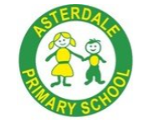
Asterdale Primary School
Whole School Long-Term Plan
‘Everyday Excellence’ – best of me, every lesson, every time, every child

Nursery FS1
  Aspiration |  |   Self-Belief |  |   Teamwork |  |   Empathy |  |  |   Resilience |   Safety
Curriculum Intent – our key drivers




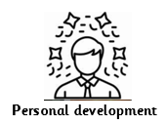
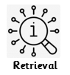



EARLY YEARS TEACHER TOOLKIT
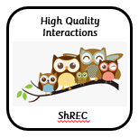
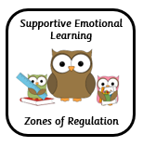
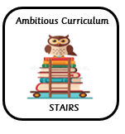
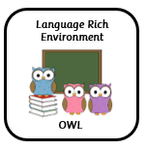

IMPLEMENTATION
 | Autumn A |  | Autumn B |  | Spring A |  | Spring B | Summer A |  | Summer B
Overarching theme | Where am I?  Ourselves |  | What do we celebrate?  Celebrations |  | Who lived happily ever after?  Traditional stories |  | How can we get to the moon?  Space | What can grow?  Growing |  | How can we get to the seaside?  Places
Reading | Little Wandle  Phonics
Focus Texts | Going to School  My Body  Super Dooper You  Someimes I feel Sunny  Hello Friend  The Family Book  Leaf Man |  | Dipal’s Diwali  Bonfire Night  All through the Night  Hannukah  Amazing  Christmas Nativity  Stickman |  | The Snowy Day  Goldilocks  Three Little Pigs  Bully Goats Gruff  Elves & Shoemaker  Enormous Turnip |  | Whatever Next  My Pet Star  Astro Girl  On the Moon  Planet Earth  Spring/Easter | Jasper’s Beanstalk  Flora’s Flowers  Tilly plants a Tree  Errol’s Garden  Oliver’s Vegetables |  | Mr Bear’s Holiday  Hundred Decker Bus  Amazing Aeroplanes  Duck in a Truck  The Train Ride  Sally & the Limpet  Once Upon a Tide  Rainbow Fish
Drawing Club Texts |  |  |  |  |  |  |  | N2 activity link with focus texts above
Maths   | More than, fewer than, same  Explore and build with shapes  Explore repeats  Hear and say number names  Begin to order number names  1 see 123  Join in with repeats  Explore position and space  Show me 123  (14wks) |  |  |  | Move and label 123  Explore position and routes  Explore own patterns  Take and give 123  Match talk, push & pull  Talk about dots  Compare and sort collections  (12wks) |  |  | Lead on own repeats  Starts to puzzle  Making patterns together  Make games together  Show me 5  My own pattern  Stop at 12345  Match sort and compare  (13wks)
Understanding the World  Science | Seasons – autumn  Healthy Bodies |  | Light and dark |  | Seasons – winter  Everyday Materials |  | Earth and Space  Seasons-spring | Lifecycles – plant focus |  | Seasons – summer  Magnets
Understanding the World  RE | Harvest  How is harvest celebrated? |  | Christmas  How and why is Christmas celebrated? |  | Friendship / working together  Who is my friend?  How can I be a good friend? |  | Easter  How and why is Easter celebrated? | Respect and care for our world  Why should we care for our world, each other and other living things? |  | Aware of differences in places  Are some places special / more important than others? Why? How?
Understanding the World  Geography | My World  Exploring ideas about the places we live or the natural world. |  |  |  | Caring for our world  Respect and care for the natural environment and all living things. |  |  | Other Places  Other places in the world, which may be different to where we live.
Understanding the World  History | Personal History – Self and family members |  | Artefacts & Objects - Shows some understanding of terms like new and old. |  | Personal History – Notices that there are children that are older than them and others that are younger. |  | Concepts of time Demonstrates some understanding of time, yesterday, last week, last term. | Personal History – link to older or younger siblings in family. |  | Concepts of time - Beginning to have an understanding for terms like, yesterday, last week and last year.
Expressive Arts and Design  Design and Technolgy |  |  | Cooking and Nutrition:  Making sandwiches |  |  |  | Structures:  Using blocks and resources |  |  | Textiles:  Fabric transient art N
Expressive Arts and Design  Art & Design | Drawing - Marvellous Marks  Exploring mark making using a range of material and tools. |  |  |  | Painting and Mixed Media – Paint my World  Exploring paint using a range of tools and techniques. |  |  | Sculpture and 3D – Creation Station  Exploring sculpture using a range of materials.
Expressive Arts and Design  Music | Sounds Around - Tuning in to environmental sounds around us.  introduction to instruments. |  |  |  | Music and Movement – Creating simple actions to songs, learning how to move to the beat. |  |  | Body Percussion & Singing - Use their voices, bodies and instruments to explore and make different sounds. Able to sing a variety of songs.
Physical Development | Exploring different ways of moving  Using a pincer grip |  |  |  | Moving freely  Joining construction materials |  |  | Moving Skilfully  Using one-handed tools and equipment
Personal, Social and Emotional Development  PSHE / RSE  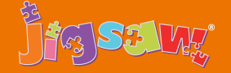 | Being me in my world |  | Celebrating Differences |  | Dreams & Goals |  | Healthy Me | RSE – Relationships |  | RSE – Changing Me
 | Self identity  Who Me?  How am I Feeling?  Being at nursery  Gentle Hands  Our Rights  Our Responsibilities |  | Identifying talents  Being special  Families  Homes  Making friends  Standing up for yourself |  | Challenge  Never give up  Setting a Goal  Obstacles & Support  Flight to the Future Footprint awards |  | Body stage  Physical activity  Healthy food  Sleep  Keeping clean  Safety | Family life  Friendships  Breaking friendships  Falling out  Dealing with bullying  Being a good friend |  | Bodies  Respecting my body  Growing up  Growth and change  Fun and fears  Celebrations
Forest Schools   |  |  |  |  |  |  |  |  | Forest School is a child-centred learning process, providing learner inspired, hands-on experiences in the natural environment. It's creative and can increase a child's confidence as they problem-solve and learn to manage risks. Forest School encourages children to explore the natural environment and learn in it. All pupils will access Forest School throughout the academic year.

