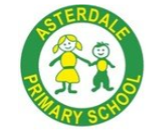
Asterdale Primary School
Whole School Long-term Plan
‘Everyday Excellence’ – best of me, every lesson, every time, every child

Year 5
  Aspiration |  |   Self-Belief |  |   Teamwork |  |   Empathy |  |  |   Resilience |   Safety
Curriculum Intent – our key drivers
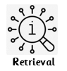

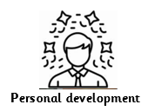






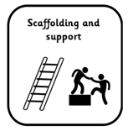
TEACHER TOOLKIT
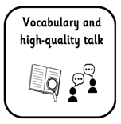
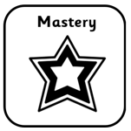
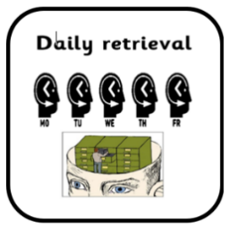
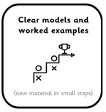
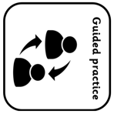
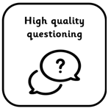

IMPLEMENTATION
 | Autumn A |  | Autumn B |  | Spring A |  | Spring B | Summer A |  | Summer B
Reading   | 1a) Flamma: The Gladiator / The Legend of Boudicca  1b) Teeth / The Digestive System  1c) Jabberwocky / The Walrus and the Carpenter |  | 2a) Pandora’s Box / King Midas and the golden touch  2b) River Trent / River Thames  2c) The Good Ferryman and the Water Nymph / An Old Dog’s Trick – A Ukranian folk tale |  | 1a) How are volcanoes formed / How are rivers formed?  1b) The Car Trip / Chocolate Cake |  | 2a) The Legend of Ragnar Lothbrok / The Blood in the Snow  2b) Romeo and Juliet Act 1, Scene 4 / Romeo and Juliet Act 1, Scene 5 | 1b) Physical Form of North America / Biomes of North America  1c) Teritary activity of the US economy / Primary resources in the US economoy |  | 2a) Visit Chichen Itza / Visit Acropolis  2b) No Problem / The British  2c) Space Tourism / Astronauts
Writing   Literacy Tree | 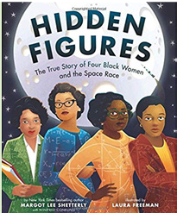 |  | 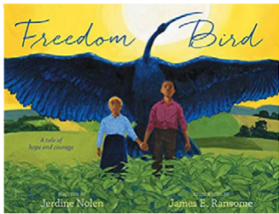 |  | 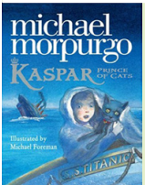 |  | 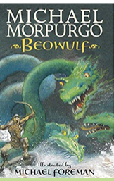 | 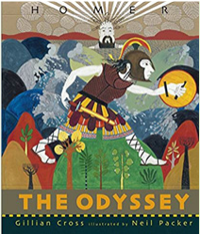 |  | 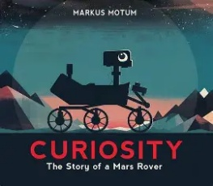
Genre | Biographies/autobiographies Information writing (Wikipedia pages), letters of advice (formal), interviews, news report, persuasive speeches |  | Biographies Non-narrative poems, explanations, dialogue, postcards, letters of advice, descriptions, recounts, narrative poems |  | Newspaper articles Character descriptions, reports, letters, advertising leaflets, balanced reports |  | Own version legends/missing chapters Letters of advice, diaries, dialogue, character and setting descriptions, action scenes, obituaries | Epic stories Speeches (proclamation, persuasive, soliloquy), dialogue, missing scenes, postcards, adverts |  | Expanded explanation for a new rover. Proposal to NASA, information labels, short explanation, NASA log of Mars landing, news report
Maths   | Number:  Place value  Number: Addition and subtraction  Number:  Multiplication and division A  Number:  Fractions A |  |  |  | Number:  Multiplication and division B  Number: Fractions B  Number: Decimals and  Percentages  Measurement: Perimeter  and area  Statistics |  |  | Geometry: Shape  Geometry: Position and direction  Number: Decimals  Number: Negative Numbers  Measurement:  Converting units  Measurement: Volume
Science   | Earth and Space  To describe the movements of the Sun, Earth and Moon.  To explore how the rotation of Earth creates day and night.  To learn about how Earth’s tilt creates seasons.  To learn about the phases of the Moon.  To discover how theories about our solar system have changed.  To investigate the planets in the solar system. |  | Forces in Action  To explain that unsupported objects fall towards the Earth because of the force of gravity acting between the Earth and the falling object  To identify the effects of friction acting between moving surfaces.  To identify and explain the effects of air resistance.  To identify and explain the effects of water resistance.  To recognise that levers and pulleys allow a smaller force to have a greater effect.  To recognise that gears allow a smaller force to have a greater effect. |  | Properties and changes of materials  To know that some materials will dissolve in liquid to form a solution  To use knowledge of solids, liquids and gases to decide how mixtures and solutions might be separated  Explain that some changes form new materials, and that these changes are not usually reversible |  | Properties and changes of materials  To identify when a change caused by heating or cooling is reversible or irreversible  To investigate the materials needed for something to burn and the new materials formed by burning  To compare and group together everyday materials on the basis of their properties  To give reasons for the particular uses of everyday materials in relation to their properties | Life Cycles  To describe the process of sexual reproduction in flowering plants.  To describe the process of asexual reproduction in plants.  To describe the process of sexual reproduction in animals.  To observe and compare the life cycles of animals in our local environment with other animals around the world.  To compare how different animals reproduce and grow  To find out about the work of naturalists. |  | Changes and Reproduction  To recognise the stages of growth and development in humans.  To know the stages in the gestation period of humans and compare them to other animals.  To recognise the stages of development during childhood and understand the needs of children at those stages.  To understand the initial changes inside and outside of the body during puberty.  To know the changes that occur during puberty and how they differ for boys and girls.  To understand how the body changes during adulthood and old age
Geography   |  |  | Biomes & Ecosystems (5)  What biomes and ecosystems are found in the UK?  What can I learn about ecosystems by studying the New Forest?  How can I study a local ecosystem?  What data can I collect from my local woodland ecosystem?  How can I present the data collected from my local ecosystem? |  | My region and the North Region of Brazil (11)  What are the key geographical features of the UK and the East Midlands region?  What is the geography of the South American continent?  What are the geographical features of Brazil?  What is the main economic activity of Brazil’s North Region?  What is the water cycle?  What are Rivers?  What are mountains?  What are the biomes and climate zones of the North Region of Brazil?  What are the vegetation belts of the North Region of Brazil?  How do the states and settlements in Brazil’s North Region compare to mine?  What are the similarities and differences between my region and the North Region of Brazil? |  |  |  |  | Rivers (4)  What are rivers, and how are they formed?  What can I learn about the River Trent?  How can I collect data from a local river in the East Midlands Region?  How can I analyse and present collected from fieldwork?
History | Anglo-Saxons and Vikings (7)  What was life in England like at the end of the 4th Century?  How did life change in England after the fall of the Roman Empire?  Why did the Anglo Saxons settle in Britain?  How was Anglo-Saxon England ruled?  How did the Anglo-Saxons keep control of their kingdoms?  How did England change through the settlement of the Anglo-Saxons and the Vikings?  Who were the Vikings and why did they carry out raids in Anglo-Saxon England? |  | Anglo-Saxons and Vikings (2)  Where did the Vikings settle and who was in control of England at this time?  What was life like in the East Midlands region during this time? |  |  |  |  | The Ancient Maya (5)  Where and when did the Maya live?  What made the Maya Civilisation so successful?  How do we know about the Maya?  How were the Maya ruled?  How was Anglo-Saxon England ruled? |  | The Ancient Maya (4)  What do we know about the Maya City States and the Anglo-Saxon Kingdoms?  How do the leaders of the Maya and the Anglo-Saxons compare?  How did the abandonment of the Southern Maya lowlands help the Northern City States to thrive?  Who was involved in the struggle for power in England from the 8th to the 10th Century?
Art & Design   | Drawing  Depth, Emotion and Movement  Exploring mark-making for showing depth, emotion and movement. Pupils are introduced to influential artists including Jean-Michel Basquiat, Charlie Mackesy, Elizabeth Catlett, and John Muafangejo. |  |  |  | Painting and Mixed Media  Portraits  Investigating self-portraits by a range of artists, children use photographs of themselves as a starting point for developing their own unique self-portraits in mixed-media. |  |  | Sculpture and 3D  Interactive Installation  Using inspiration of historical monuments and modern installations, children plan by researching and drawing, a sculpture to fit a design brief. They investigate scale, the display environment and possibilities for viewer interaction with their piece.
Design & Technology |  |  | *retrieval – textiles - fastenings  Structures: Bridges  - Arch and beam bridges  - Spaghetti truss bridges  - Building bridges  - Finalising bridges |  |  |  | *retrieval – cooking and nutrition - biscuits  Cooking and Nutrition: Developing a recipe  - From farm to fork  - Different choices  - Nutritional value  - Preparing ingredients  - Designing labels  - Making bolognese |  |  | *retrieval – digital world – mindful moments timer  Mechanical Systems: Making a Pop Up Book  - Pop-Up book page design  - Making my pop-up book  - Using layers and spacers  - Writing and illustrating
Music | Composition notation (Theme: Ancient Egypt) |  | Blues |  | South and West Africa |  | Composition to represent the festival of colour  (Theme: Holi Festival) | Glockenspiel Class lesson  (Hot House) |  | Glockenspiel  (Class lesson  Hot House)
PE   | Fitness  To understand how speed helps me in other activities and apply this.  To understand how strength helps me in other activities and apply this.  To understand how agility helps me in other activities and apply this.  To understand how balance helps me in other activities and apply this.  To understand how co-ordination helps me in other activities and apply this.  To understand how stamina helps me in other activities and apply this. |  | Parkour  To develop accuracy and control in jumping and use rolls to ensure a safe landing.  To develop flow and smooth transitions.  To develop vaulting including consecutive vaults.  To explore obstacles to gain elevation and change direction.  To build strength to climb up or move across obstacles.  To create and perform more complex flows and lead a variety of roles. |  | Handball  To send and receive under pressure.  To select skills to move toards goal, away from defenders and create space.  To combine attacking skills to create shooting opportunities.  To use defensive skills to gain possession.  To defend as a team, denying space and gaining possession.  To apply rules, tactics, skills and principles to play in a tournament. |  | Football  To develop ways to move the ball and apply them to different situations.  To send and receive under pressure.  To communicate with my team, move into space and take the ball towards goal.  To use defensive techniques to win possession.  To apply defending tactics as a team.  To use and apply skills, principles and tactics to a game situation. | Yoga  To understand how breath can help me to hold and move from pose to pose.  To identify and use balance when exploring poses and creating a flow.  To identify and use flexibility when exploring poses and creating a flow.  To identify and use strength when exploring poses and creating a flow.  To create and recline a flow with a partner.  To lead others through our flow. |  | Athletics  To understand pace and apply different speeds over varying distances.  To develop fluency and co-ordination when running for speed.  To develop technique in relay changeovers.  To build momentum and power in the triple jump.  To develop throwing with force for longer distances.  To develop throwing with greater control and technique.
 | Dance  To copy and repeat movements in the style of rock ‘n’ roll.  To work with a partner to copy and repeat actions in time with the music.  To work collaboratively with a group to choreograph a dance in the style of Rock ‘n’ Roll.  To develop set choreography inspired by a Mayan god.  To choose actions to create a motif in a given character with consideration of dynamics, space and relationships.  To use structure to choreograph a dance performance. |  | OAA  To develop communication and negotiation skills.  To develop strong communication and negotiation skills to solve challenges.  To develop planning and problem solving skills.  To share ideas and work as a team to solve problems.  To develop navigation skills and map reading.  To create and follow a key and route on a map. |  | Gymnastics  To perform symmetrical and asymmetrical balances.  To develop the straight, forward, straddle and backwards roll into a sequence.  To explore different travelling actions using both canon and synchronisation.  To perform progressions of invented movements.  To explore matching and mirroring in sequence work.  To create a partner sequence using apparatus. |  | Badminton  To use the serve with consideration of attacking principles.  To explore an underarm return with consideration of attacking principles.  To explore an underarm return with consideration of attacking principles.  To explore the overhead forehand with consideration of attacking principles.  To select and apply skills and tactics to play competitively.  To apply rules, skills and tactics to play in a tournament. | Tennis  To return the ball using a forehand groundstroke under pressure.  To return the ball using a backhand groundstroke under pressure.  To use a variety of shots to keep a continuous rally going.  To develop the underarm serve and understand the rules of serving.  To develop the volley and understand when to use it.  To apply rules, skills and principles to play against an opponent. |  | Rounders  To develop throwing and catching skills and apply them relevantly to the situation.  To develop bowling accuracy and perform the skill within the rules of the game.  To develop batting skills, identify when I am successful and what I need to do to improve.  To develop fielding techniques and begin to use these under pressure,  To understand the need for tactics and identify when to use them.  To apply skills and knowledge to compete in a tournament, using tactics identified.
COMPUTING | Wk 1: Online Safety:  Online Relationships  SMART rules |  | Wk 1: Online Safety:  Online Bullying |  | Wk 1: Online Safety:  Online Reputation  Privacy and Security |  | Wk 1: Online Safety:  Managing Online Information | Wk 1: Online Safety:  Copyright & Ownership |  | Wk 1: Online Safety:  Health, well-being & lifestyle  Self-image & identity
COMPUTING | Computing systems and networks  (Search engines)  Can they explain how a search engine is useful to find website and information?  Do they know what ‘TASK’ stands for?  Do they consider the terms ‘copyright’ and ‘fair use’ when combining texts or images in a poster?  Can they make parallels between book searching and internet searching? |  | Programming  (Programming music)  Can they add loops to their work?  Can they correct their own simple mistakes?  Can they include a repeat and explain its function to enhance music?  Can they code a piece of music which combines a veriaty of structures? |  | Creating media  (Stop motion animation)  Can they create a toy with simple images and a single movement?  Can they create a short stop animation?  Can they make changes to to ensure a smooth animation?  Can they add effects such as extending parts and titles? |  | Programming  (Micro:bit)  Can they recognise the difference between ‘on start’ and ‘forever’?  Can they create their own images to make an animation?  Can they identify inputs and outputs to make predictions about how variables work?  Can they break a program down into smaller steps and match it to an algorithim? | Data handling  (Mars Rover 1)  Can they identify the types of data the Mars Rover would collect?  Can they explain how the Mars Rover data is transmitted back to Earth?  Can they read binary numbers?  Can they dientify input, processing and output on the Mars Rover? |  | Online safety  Do they understand why and how a password is considered strong?  Can they differentiate between different types of online communication?  Can they search for simple information about a person?  Can they recognise when health and wellbeing are being affected online?  Do they know how to respond to negative online behaviours?  Do they know who to ask for help if they have any worries online?
MFL   | Phonetics 3  Les legumes  Vegetables  Can they recognise and recall 5 vegetables with the correct plural determiner/article in French?  Can they recognise and recall 5 more vegetables and the plural determier/article in French?  Can they construct a question to ask for a kilo or half a kilo of a vegetable in French?  Can they use the structure ‘je voudrais’ (Iwould like) when buying vegetbles?  Can they use the conjunction ‘et’ (and) when buying more than one vegetable option? |  | La date  The date  - Can they repeat all the days and months in French from memory with pronunciation and spell some of them correctly?  - Can they ask the date in French and say the date in French?  - Can they ask when somebody has their birthday in French?  - Can they tell them when they have their birthday in French?  Can they say a short sentence about what day of the week it is in French?  Can they recall and spell numbers 1-31 in French? |  | En classe  In the classroom  Can they remember and recall 12 classroom objects with their indefinite article/determiner?  Can they replace an indefinite article/determiner with a possessive adjective?  Can they say and write what they have and do not have in their pencil case? |  | Chez moi  My home  Can they say whether they live in a house or an apartment and say where it is?  Can they repeat, recognise and attempt to spell up to ten nouns (including the correct article for each) for the rooms of the house in French?  Can they tell somebody in French what rooms they have or do not have in their home?  Can they ask somebody else in French what rooms they have in their home?  Can they attempt to create a longer spoken or written passage in French recycling previously learnt language (incorporating personal details such as their name and age)? | Boucle d'Or et les Trois Ours  Goldilocks and the three bears  Can they listen to the familiar fairy tale of Goldilocks and the Three Bears in French and understand the meaning using picture cards?  Can they re-listen to the familiar fairy tale and retain more new vocabulary in French using picture cards?  Can they re-listen to the familiar fairy tale and consolidate their new knowledge in French with phrase cards?  Can they use their knowledge to re-write the story of Goldilocks and the Three Bears in French?  Can the children present their version of the story to the class |  | Ma famille  My family  Can they tell somebody the members, names and various ages of either their own or a fictional family in French?  Can they continue to count in French, with the option of reaching 100, enabling students to say the age of various family members.?  Do they understand the concept of the possessive adjectives ‘mon’, ‘ma’ and ‘mes’ in French?  Can they move from 1st person singular to 3rd person singular of the two high frequency verbs used in this unit: s’appeler (to be called) and avoir (to have)?
PSHE / RSE   | Being Me in my World |  | Celebrating Difference |  | Dreams & Goals |  | Healthy Me | Relationships |  | Changing Me
 | Identifying goals for the year  Global citizenship  Children’s universal rights  Feeling welcome and valued  Choices, consequences and rewards  Group dynamics  Democracy, having a voice  Anti-social behaviour  Role-modelling |  | Perceptions of normality  Understanding disability  Power struggles  Understanding bullying  Inclusion, exclusion  Differences as conflict, difference as celebration  Empathy |  | Personal learning goals, in and out of school  Success criteria  Emotions in success  Making a difference in the world  Motivation  Recognising achievments  Compliments |  | Taking personal responsibility  How substances affect the body  Exploitation including ‘county lines’ and gang culture  Emotional and mental health  Managing stress | Mental health  Identifying mental health worries and sources of support  Love and loss  Managing feelings  Power and control  Assertiveness  Technology safetyTake responsibility withtechnology use |  | Self-image  Body image  Puberty and feelings  Conception to birth  Reflections about change  Physical attraction  Respect and consent  Boyfiends/girlfriends  Sexting  Transition
RE | Worship  What is worth and what does it mean if something has ‘worth’?  How does music make you feel and why is it used in worship?  Why is art important to worshippers?  How and why do believers pray?  How are artefacts used in worship in different faiths? |  | The True Meaning of Christmas  What is the true meaning of Christmas to Christians?  What is love?  What does incarnation mean and how does it relate to Christmas?  How are Christian Christmas cards different to secular ones?  What do some carols mean? |  | Peace  What does ‘peace’ mean?  What does peace mean in different religions?  What is ‘inner peace’ and how do believers try to find it?  What is community cohesion and how does it support peace?  What symbols represent peace? |  | Forgiveness  What is forgiveness?  What do Jews believe about forgiveness?  Why is Yom Kippur important for Jews?  What do Buddhists believe about forgiveness?  How is forgiveness similar and different in Buddhism and Judaism? | Jesus the Healer  What is a miracle?  Why did Jesus perform miracles?  Were Jesus’ miracles the same? |  | Commitment  What is commitment?  How is commitment demonstrated in coming-of-age ceremonies?  What is sacrifice and why do people make sacrifices?  How does fasting show commitment?  What happens during a Hindu wedding?  How do we remain committed?  What different ways do adults show commitment to each other?
Forest Schools   | Forest School is a child-centred learning process, providing learner inspired, hands-on experiences in the natural environment. It's creative and can increase a child's confidence as they problem-solve and learn to manage risks. Forest School encourages children to explore the natural environment and learn in it. All pupils will access Forest School throughout the academic year.

