
Implementation Expectations
Reading
Scheme   | 
Timetable/Duration | Minimum 25/30 minute lesson 4 times a week
Lesson Structure  (What a typical lessons look like) | 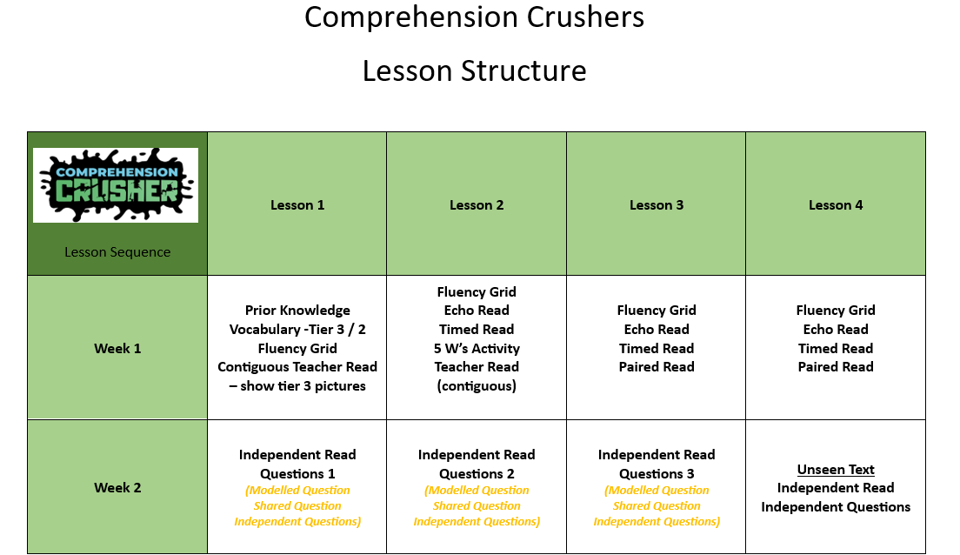
Expectations in Books | - Recorded from Week 2 of the sequence  - Short/Number date at top of page  - WALT recorded at top of page (pupil written / labelled by staff as appropriate)  - WALT to use content domains  - Children to complete work in pencil  - Teacher marking in blue/green pen  - Pupil corrections / self-assessment in purple pen
Retrieval opportunities | - Prior knowledge revisited – links to other areas of the curriculum  - Repeated reading  - Daily retrieval of vocabulary  - Working Wall
Assessment | - Teacher marking  - Pupil self/peer assessment  - Verbal feedback from teacher/TA  - Pixl reading assessments / SATs
Working Wall | - Unit of work  - Vocabulary  - Supporting resources  - Content domain hexagons
Marking & Feedback | Follow Marking & Feedback Policy
SEND Adaptations | - Use of Teacher Toolkit  - Adaptation of application activities  - Use of visualiser  - Repeated reading  - Oral rehearsal and answering of questions  - Echo reading

