

Asterdale Adaptation Offer

The following elements are expected within our teaching practice at Asterdale
to ensure high-quality learning for all pupils:

Positive, high expectations and aspirations for all

‘Good teaching for pupils with SEND is good teaching for all’

Curriculum is structured, pre-planned and prepared sequence of lessons

Value based curriculum: 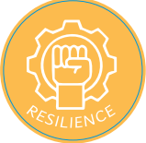

Teacher Toolkit: High Quality Teaching

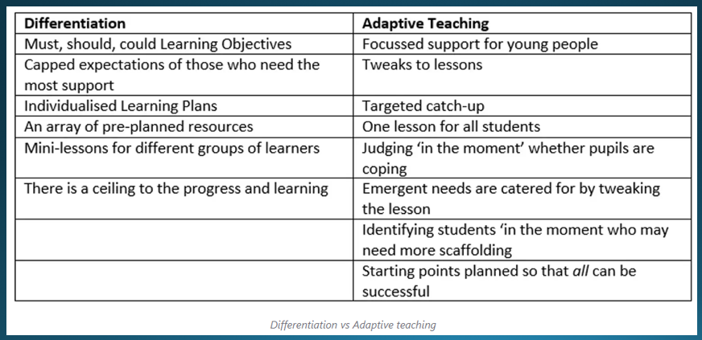

Daily retrieval  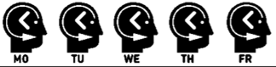  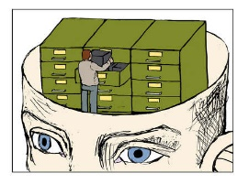  (entry and exit quiz)  - Frequent checking of understanding  - Knowing more and remembering more  - Exit and entry quizzes  - Cumulative quizzes  - Daily starter  - Flashback in 4  - Check in times – check what pupils already know and act of the feedback  - Stop & Jot / Pit stop | High quality questioning    (to check for meaning and to deepen understanding)  - High quality questioning  - Focus on bottom 20%  - Adapt questioning  - Question to their adapted WALT  - Ask children for feedback during the lesson – how are they finding the challenge of the lesson  - Ask what questions do you have rather than do you have any questions  - Answer questions on whiteboards – all pupils are involved – hold up at the same time  - Manage thinking time for answering questions – count to 5  - Peer talk / TA talk before answering questions – rehearse  - Use tell me more… | Clear models and worked examples  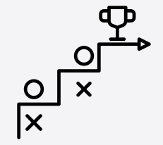  (new material in small steps)  - Visualisers  - ‘What a good one looks like’  - Modelled answers and writing  - Teacher modelling of the desired response  - Showing children’s work  - Modelling handwriting  - Editing and improving  - Working Walls | Scaffolding and support      (so difficult concepts are accessible to all - including SEND adaptations)  - Chunking – breaking down lessons into small staps – clarity of instructions  - Highlight SEND core content / WALT  - Phonics mats/ Number squares on desks  - Visual timetables- ‘Now and Next’  - Now and Next  - Knowledge organisers  - Whiteboards  - Concrete resources – manipulatives in maths  - Handwriting mats / writing frames  - Seating – near the teacher, near the TA  - Support packs  - Flip cards  - TA prompts – (prompt not give the answer)  - Success Criteria  - TA feedback on how the pupils are learning  - Seating & grouping pupils  - Rainbow Grammar  - Graphic organisers  - Recording devices  - Pupils highlight and use post-it to provide feedback
Vocabulary and  high-quality talk      (agreed model for  teaching new vocabulary)  (sentence stems)  - Explicit teaching of vocabulary  - Dictation  - Paired talk / peer work  - Feedback prompts / sentence stems  - Verbalise answer  - Vocabulary mats  - Dual coding  - Vocabulary – sound buttons  - Pre-highlighting challenging vocabulary  - Word banks | Mastery approach    (high expectations for all)  (teachers showcase deep  subject knowledge)  - SEND children are entitled to think hard  - Hexagons – word path ways  - 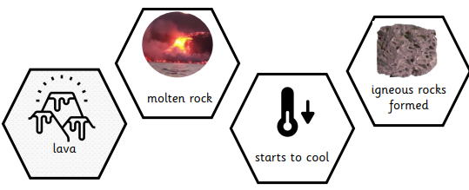 | Guided practice    (my turn, our turn, your turn)  - my turn, our turn, your turn  - Modelled example, shared example, independent work  - Review, repeat, recall, retrieve – DO NOW  - Feedback and Live marking | Encouraging independence    (over-learning so that learning is stored in long-term memory)  - TA – appropriate support not dependence  - Children complete the work themselves  - Scaffolding is temporary – remove when pupils develop competence
_Adjusted expectations, but not allowed to avoid learning
- Calm down time
- Worry Boxes
- Fidget toys
- Ear defenders
- Radio Aid
- Safe spaces – classroom, outside the classroom, soft-landings
- Specific tasks on entry
- Outdoor access / sensory circuits
- Change of adult 1-1 support to widen social opportunities
- Intervention groups – phonics
- Interventions to address need identified in mathematics re: place value tens and units, ordering of number 1-20, number bonds to 10, multiplication using efficient method
- Intervention – handwriting
- Gaps analysis of assessment – PIXL and PIXL therapies

