
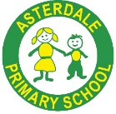
Music development plan summary:
Asterdale Primary School

Overview
Detail | Information
Academic year that this summary covers | 2024-2025
Date this summary was published | September 2024 (Amended version)
Date this summary will be reviewed | July 2025
Name of the school music lead | Kerry Knowles
Name of school leadership team member with responsibility for music (if different)
Name of local music hub | Derbyshire Music Hub
Name of other music education organisation(s) (if partnership in place) | Hot House

This is a summary of how our school delivers music education to all our pupils across three areas – curriculum music, co-curricular provision and musical experiences – and what changes we are planning in future years. This information is to help pupils and parents or carers understand what our school offers and who we work with to support our pupils’ music education.

Part A: Curriculum music
This is about what we teach in lesson time, how much time is spent teaching music and any music qualifications or awards that pupils can achieve.
School Year 2023-24
- Asterdale Primary School provides high quality music provision through a planned, sequenced music curriculum, where,
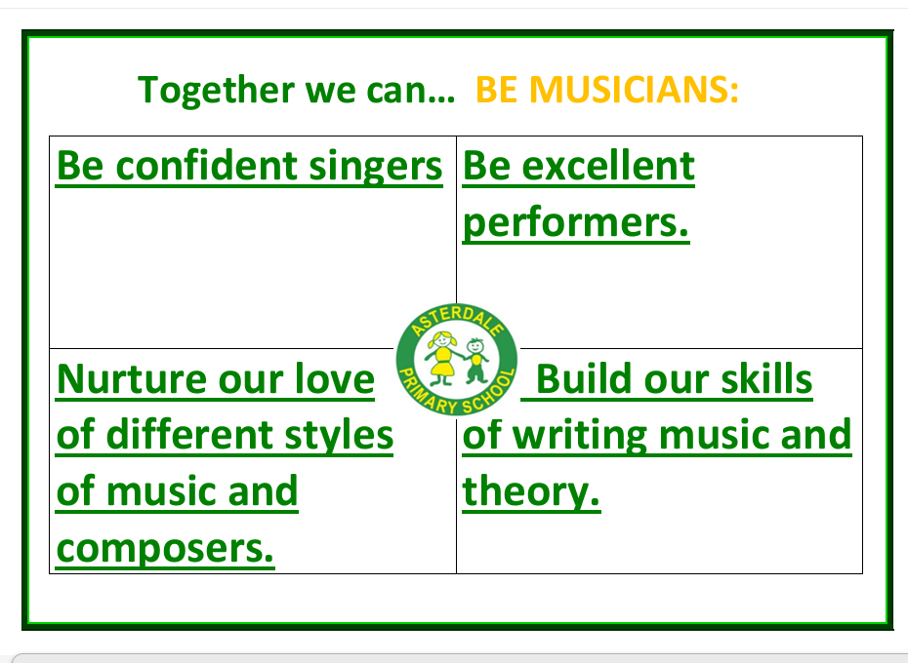
- The ‘Kapow Music Scheme’ is followed from EYFS through to the end of KS2, to provide sequenced weekly lessons delivered by class teachers across the school and ‘Hot House’ music specialists in year 3 and year 4. KAPOW is based on the National Curriculum. Pupils access at least one hour of music provision per week.

KAPOW Scheme Overview
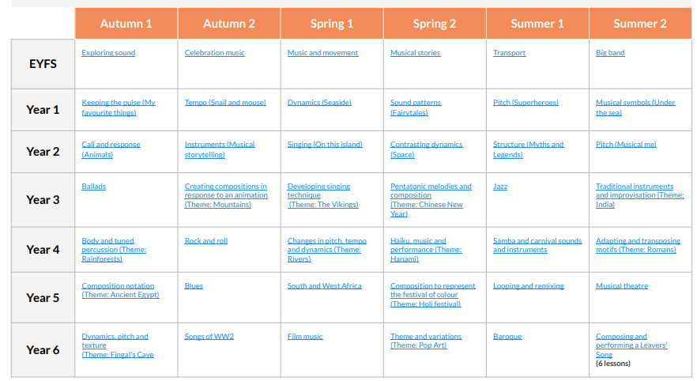
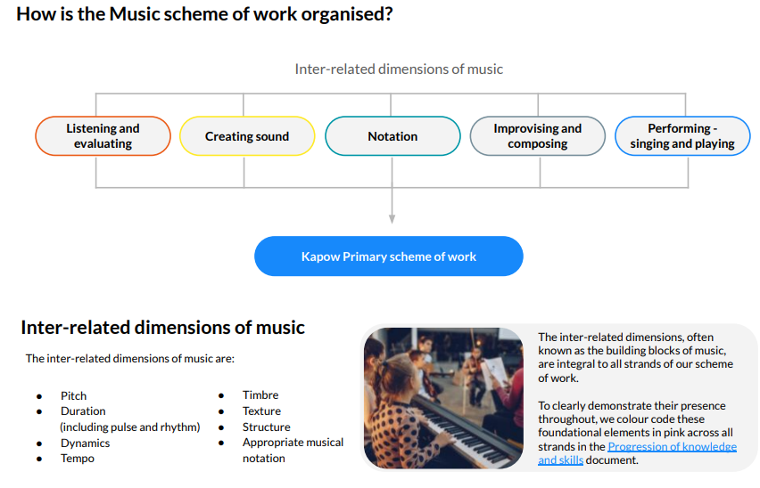
- A key progression of skills document sets out clear standards of expectations of skills and knowledge to be achieved in music by the end of each year group as shown on the school website.
- There is a long-term plan to show how in specific topics a range of music genre are explored, for example, in Year1 All about Me topic focusses on pulse and rhythm (as shown on the school website)
- Assessment of skills and knowledge learnt is both through formative assessment and summative, such as through retrieval practice, key questions, end of unit assessment quiz’s (evidence in books) and visual assessments by teachers.
- Kapow provides sample videos for each session to aid staff CPD and ensure knowledgeable, effective delivery.
- Years 3, 4 and 5 access whole class instrument lessons in ukulele.
- A class set of Major key Glockenspiels was purchased with a recourse grant. This will promote whole class learning, year 6 are intending to use them in their Leavers Assembly for parents. They will enable classes to develop their skills using Tuned Percussion.
- Whole school singing continues weekly in assemblies and also within KAPOW music lessons.
- Additional opportunities for performance are in concerts, assemblies in school and whole school community visits, for example, the local church.
- Pupils in KS2 are part of the school choir who have successfully performed at the local nursing home, in Asda and the Co-op supermarkets with supporting audiences.
- The school works with Hot House music specialists, and the Derbyshire Music Hub, to enhance instrumental teaching and learning opportunities.
- In addition, whole school workshops have enabled pupils to access African drumming, Bollywood and Greek dancing.
- There are annual theatre trips for EYFS to Y6 pupils to see live musical performances

Part B: Co-curricular music
This is about opportunities for pupils to sing and play music, outside of lesson time, including choirs, ensembles and bands, and how pupils can make progress in music beyond the core curriculum.
- Asterdale Primary School values working with external music specialists. ‘Hot House’ music specialists offer one to one tuition in a range of instruments to pupils in KS2. A key focus has been on Ukulele.
- Pupils in KS2 are invited to join the school choir. This will be widened in future plans.
- The school provides a breakfast and after-school clubs where music opportunities are included depending on the interests of pupils attending.
- Asterdale Primary School, as part of Odyssey Collaborative Trust, have a charging and remissions policy which includes information on contributions towards individual music tuition, that is in addition to curriculum provision provided through the school national curriculum.
- Pupils can rehearse or practice individually or in groups in the school hall, in classrooms, corridor spaces, playgrounds and on the fields.

Part C: Musical experiences
This is about all the other musical events and opportunities that we organise, such as singing in assembly, concerts and shows, and trips to professional concerts.
At Asterdale Primary School musical events include both annual and other music events to broaden the range available. These include
- Pupils are given opportunities to perform in special assemblies eg. Harvest, Christmas, Easter end of year concerts across the school. In these pupils learn a variety of songs to sing and perform, listen to music and play instruments. These are planned so that pupils from different year groups are involved.
- Leavers’ concerts
- Choir special performances (KS2) in school and in the wider community.
- Pupils listen to a variety of classical musical on entry to assemblies.
- Through PE lessons pupils perform to music and a local dance teacher provides expertise in particular styles eg Bollywood.
- The PTFA provide frequent discos using pop music from a range of years

In the future

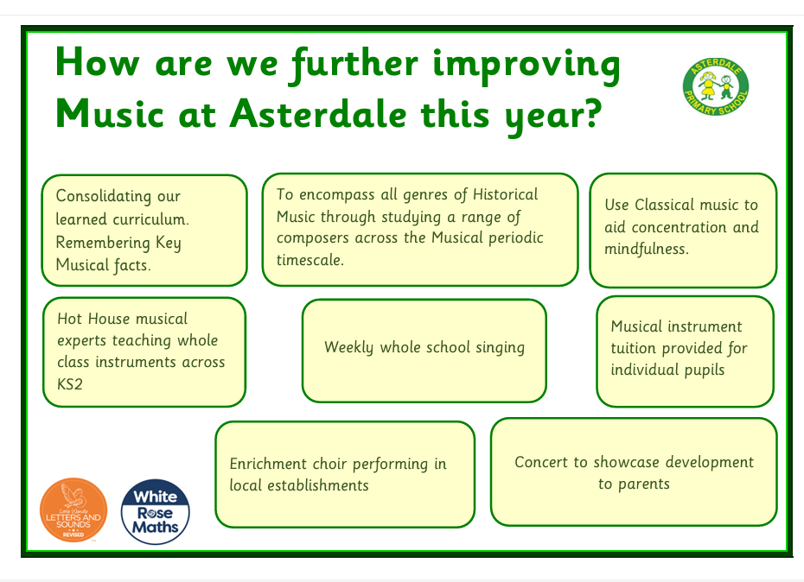

Development plan for 2024-2025
DfE features of high-quality school music provision | Current provision | Planned development over the next 2 years | Possible Music Specialist Support | Progress/What’s next?
- Curriculum provision | Use Kapow Scheme in all years.  Skills progression followed throughout scheme.  1-hour weekly provision in each class delivered by class teachers and Hot House specialists | Explore further ways to track progression of musical learning in a manageable way.  Provide staff CPD on following individual musical elements, KS2 notation and historical genres.  KS1 singing and performing | Meet with curriculum consultant from Music Hub. | Develop provision for Early years and KS1
- Whole class instrumental teaching | All children have access to Recorders (Y6,5 and 3), bell ringing and singing. | Rolling programme throughout school, possibly with different instruments | Liaise with lead on what instruments.  Provide singing workshops
- Access to lessons across a range of instruments and voice | Provide guitar, drums, ukelele, violin, choir. Advertised through assemblies, letters home | Wider range of musical instrument provisions. 1-1 lessons taught on woodwind and brass.
- Develop a school/vocal ensemble | Established choir in place, weekly rehearsals. Cover wide range of genres of music, theatre, modern etc | Develop KS1 singing group
- Develop a school ensemble/band/group | No instrumental ensemble at moment other than whole class.  Pupils perform to parents and peers for concerts, church services, recordings taken and put on Dojo throughout the year | Approach Hot House to put together ensemble for a concert from pupils taking 1/1 tuition.
- Provide space for rehearsals and individual practice | 1/1 lessons take place in the Hub, practice area provided. Storage for instruments in classrooms and music store.
- Develop a termly performance | Performances are at Harvest, Christmas Easter and Leavers assembly. Small group performances encouraged at local community spots, Asda, Nursing Homes and Church. | Plan in place to perform a whole mat song at Christmas. | Music Hub support for accessing orchestral performances.
- Provide opportunities to enjoy live performances at least once a year | Annual theatre trips for ks1 and ks2  Visiting performers and workshops in school.  African drumming, and dancers. Bollywood and Greek dancers. Hot House instrument performances, storytelling and song workshops. | Provide info on extracurricular groups, workshops, holiday clubs and bands in the local area to signpost parents to what opportunities are available for children outside school.

Further information
Our local music hub is Derbyshire Music Hub Derbyshire Music Hub. Our local music hub should also have a local plan for music education in place from September 2024 that will include useful information.
The Department for Education publishes a guide for parents and young people on how parents can get involved in music in and out of school, and where they can go to for support beyond the school.

