Promoting the Protected Characteristics at Asterdale Primary School
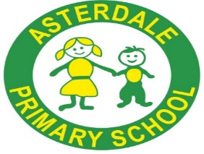
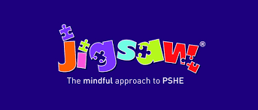

The Equality Act of 2010 brought together anti-discrimination laws into one single act, so any unlawful treatment relating to one of the Equality Act protected characteristics, since 2010 is covered by this area of law. It covers everyone in Britain and protects people from discrimination, harassment and victimisation. This is because the Equality Act (2010) protects people against discrimination because of the protected characteristics that we all have.

Under the Equality Act (2010), there are nine Protected Characteristics:
- Age
- Disability
- Gender reassignment
- Race
- Religion or belief
- Marriage or civil partnership
- Sex
- Sexual orientation
- Pregnancy and maternity

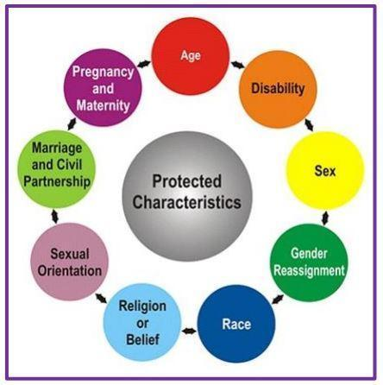

In 2020 Ofsted published guidance to schools on teaching the protected characteristics in school. It is important that all children have an understanding of the world they are growing up in, having learned how to live alongside, and show respect for, the diverse range of people in their community.
At Asterdale Primary School, we actively promote the protected characteristics in our curriculum and we continually work to embed them into our school culture and ethos, as part of PSHE lessons and in the wider curriculum and school life.

The Jigsaw PSHE 3-11 scheme helps to understand and promote these characteristics more fully and in a pupil-centred way. The inclusive approach starts with children in Nursery and Reception (ages 3-5) and continues to develop through the age ranges. The Jigsaw approach is progressive and developmental.
Ground rules are fundamental to creating and maintaining an inclusive and safe teaching and learning environment. Establishing such an environment for both pupils and teachers is important for PSHE education lessons – especially those focusing on equality and the protected characteristics, as it:
- Enables them to feel comfortable exploring values and attitudes
- Enables them to express their own opinions and consider the views and opinions of others, without the fear of negative feedback, and only if they choose to.
In Jigsaw PSHE this happens in every lesson. We promote a safe, open and inclusive learning environment based on trusting relationships between all members of the class, adults and pupils alike. To enable this, we ensure that the ‘ground rules’ are agreed and owned at the beginning of the year and are reinforced in every Piece – by using The Jigsaw Charter. Pupils take ownership of the Jigsaw Charter. One of the most important elements of the Charter is the Right to Pass, where pupils understand that they do not have to participate in the discussion/activity if they do not wish to. This creates a space where they can feel safe and their wishes are taken seriously by adults and peers alike. This is vital when teaching about safeguarding in both an implicit and explicit way. They choose whether they speak or not and their right to pass is upheld and respected. The Jigsaw Charter refers to confidentiality too. It is important that pupils are taught to respect the privacy of others and to do their best to keep personal information or views shared by their classmates in Jigsaw Pieces (lessons) confidential, and not to share personal information about themselves or others. Teachers emphasise that adults cannot promise complete confidentiality as they must report any information relating to safeguarding concerns. Children are encouraged to discuss the ideas and learning in their lessons at home, but to show their classmates the respect and privacy that they would want in return.
In terms of content, the Puzzle ‘Celebrating Difference’ is the most pertinent of units for teaching about the protected characteristics, as it focuses on similarities and differences and teaches about diversity, such as disability, racism, gender, family composition, friendships, and conflict. Children in our school learn to accept everyone’s right to ‘difference’, and year groups explore the concept of ‘normal’. Bullying – what it is and what it isn’t, including cyber and homophobic bullying – is an important aspect of this Puzzle.
Additionally, the ‘Relationships’ Puzzle also has a wide focus, looking at diverse topics such as families, friendships, equality in relationships, and love and loss – all of which can help to deliver the vital messages behind the Equality Act. A vital part of this Puzzle is about safeguarding and keeping children safe; this links to cyber safety and social networking, as well as attraction and assertiveness; children learn how to deal with conflict, their own strengths and self-esteem. They have the chance to explore roles and responsibilities in families and look at stereotypes. All Jigsaw lessons are delivered in an age- and stage-appropriate way so that they meet pupils’ needs and can help them understand the wider world.
Our Jigsaw PSHE lessons are aligned to the Equality Act 2010. Potentially vulnerable young people are supported through the Jigsaw content, and all pupils are gently made aware of their rights and responsibilities in their local and wider communities. The age and religious background of all pupils are taken into account. We ensure that teaching is respectful, sensitive and that the needs of all pupils are appropriately met.

Other ways that we embed a culture of developing pupils’ understanding of the protected characteristics is by learning about and advocating equality and diversity. Some examples of ways that we do this is through literature, assemblies, visits in the community, focus days and celebrations of festivals. Our intention is through the books we use to ensure that gender and gender identity, religion, race, sexual orientation, disability and age is explored. The focus of the literature is to notice, celebrate and develop resilience around diversity. Through discussion, children are encouraged to show respect and develop their understanding of diversity.

The grid below demonstrates an overview as to how particular Jigsaw lessons pertain to protected characteristics. The list is not exhaustive as there are numerous other lessons that teach about equality.

Protected characteristics | What this refers to Links to Jigsaw 3-11
Age | Where this is referred to, it refers to a person belonging to a particular age (for example, 32-yearolds) or range of ages (for example, 18- to 30-yearolds). | Celebrating Difference  Year 4 Piece 1: Judging by Appearance  Year 4 Piece 2: Understanding Influences  Year 6 Piece 2: Understanding Difference  Year 6 Piece 3: Power Struggles
Gender reassignment | The process of transitioning from one gender to another. | Celebrating Difference  Year 2 Piece 5: Gender Diversity  (NB: there is no direct reference to transgender or the concept of transitioning in this lesson).  Year 6 Piece 2: Understanding difference  (NB. In Jigsaw the focus is on accepting all people as unique individuals, not on transitioning itself).
Being married  or in a civil partnership | Marriage is no longer restricted to a union between a man and a woman but now includes a marriage between a same-sex couple. Same-sex couples can also have their relationships legally recognised as ‘civil partnerships’. Civil partners must not be treated less favourably than married couples (except where permitted by the Equality Act). | Celebrating Difference Year 3 Piece 1:Families  Year 6 Piece 2: Understanding Difference  Relationships  Year 1 Piece 1: Families  Year 2 Piece 1: Families

Being pregnant or on maternity leave | Pregnancy is the condition of being pregnant or expecting a baby. Maternity refers to the period after the birth, and is linked to maternity leave in the employment context. In the non-work context, protection against maternity discrimination is for 26 weeks after giving birth, and this includes treating a woman unfavourably because she is breastfeeding. | Celebrating Difference  Nursery & Reception-5 Piece 3: Families  Year 4 Piece 1: Families  Year 6 Piece 2: Understanding Difference
Disability | A person has a disability if she or he has a physical or mental impairment which has a substantial and long-term adverse effect on that person’s ability to carry out normal day-to-day activities. | Celebrating Difference  Year 6 Piece 5: Celebrating difference  Year 2 Piece 4: Standing up for Myself and others  Year 4 Piece 1: Judging by Appearances  Year 4 Piece 6: Celebrating Differences: How We Look  Year 6 Piece 2: Understanding Differenc
Race including colour, nationality, ethnic or national origin | Refers to the protected characteristic of Race. It refers to a group of people defined by their race, colour, and nationality (including citizenship) ethnic or national origins. | Celebrating Difference  Year 5 Piece 1: Different Cultures  Year 5 Piece 2: Racism  Year 3 Piece : Families  Year 6 Piece 2: Understanding Difference
Religion, belief or lack of religion/belief | Religion has the meaning usually given to it but belief includes religious and philosophical beliefs including lack of belief (such as Atheism). Generally, a belief should affect your life choices or the way you live for it to be included in the definition. | Celebrating Difference  Ages 9-10 Piece 1: Different Cultures  Age 10-11 Piece 2: Understanding Difference
Sex | A man or a woman. | Celebrating Difference  Year 2 Pieces 1 & 2: Boys and Girls  Year 4 Piece 1: Judging by Appearances  Year 6 Piece 2: Understanding Difference  Changing Me  Year 3 Piece 5: Family Stereotypes
Sexual orientation | Whether a person’s sexual attraction is towards their own sex, the opposite sex or to both sexes. | Celebrating Difference  Year 2 Piece 4: Standing up for Myself and others  Year 3 Piece 1: Families  Year 5 Piece 3: Rumours and Name Calling  Year 5 Piece 4: Types of Bullying  Year 6 Piece 2: Understanding Difference  Relationships  Year 4 Piece 5: Girlfriends and Boyfriends  Changing Me  Year 6 Piece 4: Boyfriends and girlfriends




