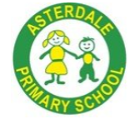
Implementation Expectations
Science

Scheme | 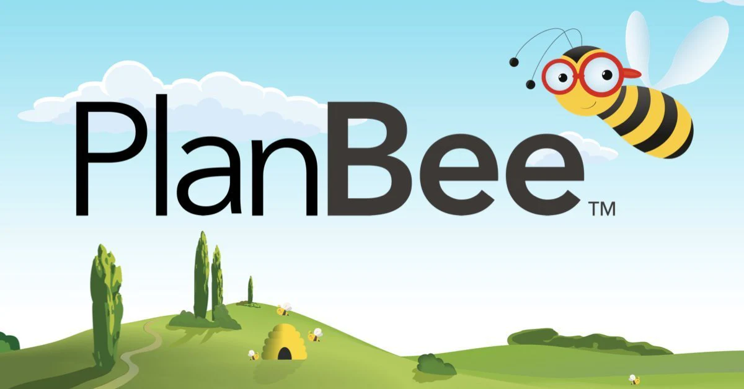  All planning and resources are on the public drive.  Curriculum – Science – Plan Bee Scheme of work – Year Group
Timetable / Duration | - Every week weekly in a discrete 1 hour lesson.  - Sometimes experiments may require a double science lesson to see them through from start to finish and write them up.
Lesson Structure  (What a typical lessons look like) | - Retrieval / recap from previous lesson at the beginning of every lesson.  Use ‘presentation mode’ in Kapow and follow through the slides.  - Learning Objective  - Success Criteria  - Key Vocabulary  - Attention Grabber (Questions to consider) videos to watch.  - Main event/input  - Independent activities  - Wrapping Up/Quiz
Expectations in Books | - Short date and WALT at the top of the sheet  - Pre & Post test at the beginning & end of every unit.  - Written retrieval tasks stuck in books.
Retrieval opportunities | - Retrieval section at the beginning of every lesson – knowledge and vocabulary  - Working Wall  - Brain Dump, List it, Give me 5, Frayer model, What am I?  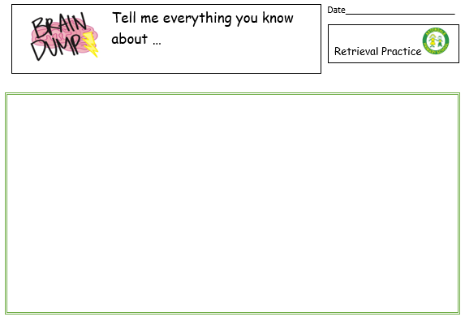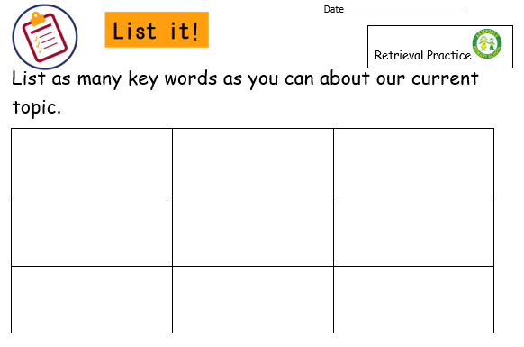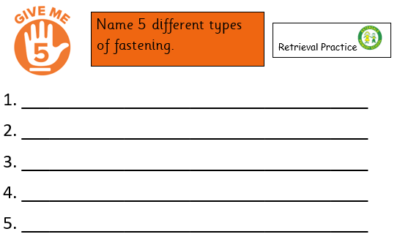  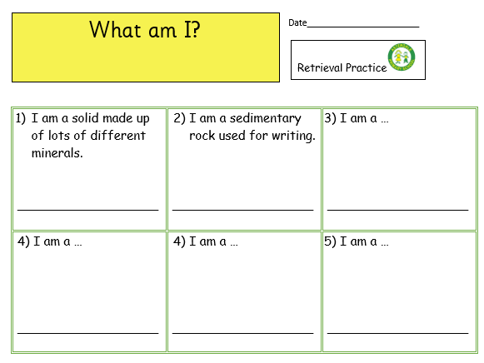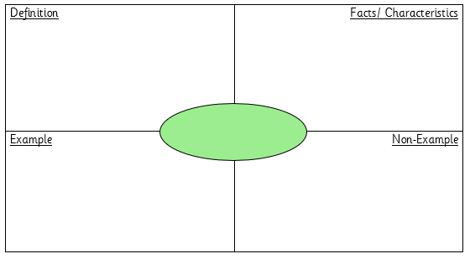
Assessment | - Use the PlanBee assessment/quiz of multiple choice.  - Complete the assessment/quiz at the beginning and end of each unit and stick in books.  - Record children’s scores on the assessment tracker sheet and then complete the teacher assessment column for each unit.  - Send an electronic copy of the updated assessment tracker via email to subject lead (AH) after each unit has been completed.  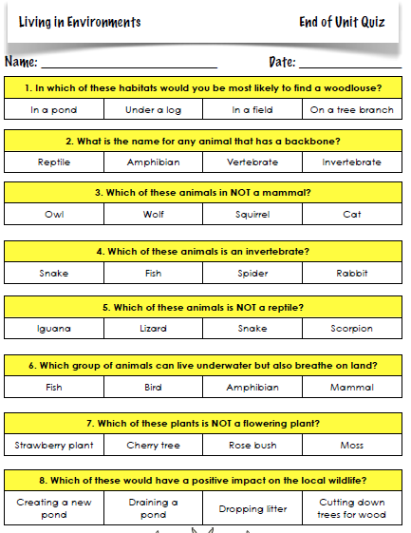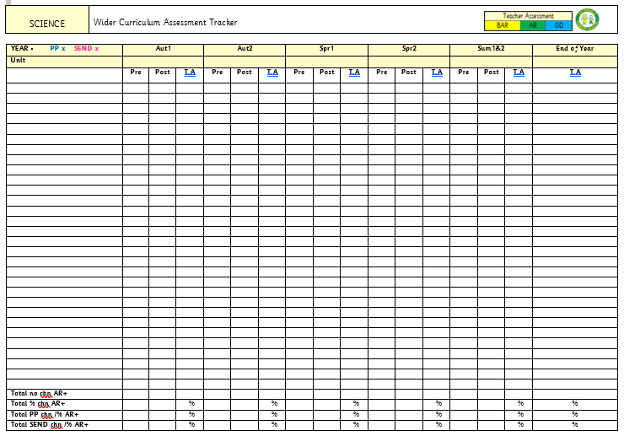
Working Wall | - Display the title of the unit.  - Vocabulary dozen for the current unit.  - Examples of children’s work.  - Photographs of any practical lessons.  - Diagrams to aid understanding
Marking & Feedback | Follow Marking & Feedback Policy
SEND Adaptations | - Use of Teacher Toolkit  - Adaptation of independent activities – Plan Bee have 3 different sheets per lesson. SEN complete ‘sheet A’ where appropriate.  - Scaffolding  - Teacher/TA support

