
Implementation Expectations
French

Scheme | 
Timetable / Duration | 45 minutes per week
Lesson Structure  (What a typical lessons look like) | Retrieval / recap from previous lesson at the beginning of every lesson  Key Vocabulary based on Reading, Speaking and Listening tasks  Application Activity  End of Unit assessment
Expectations in Books | Date in French  Retrieval sheet if used  Activity sheet  End of Unit assessment sheet  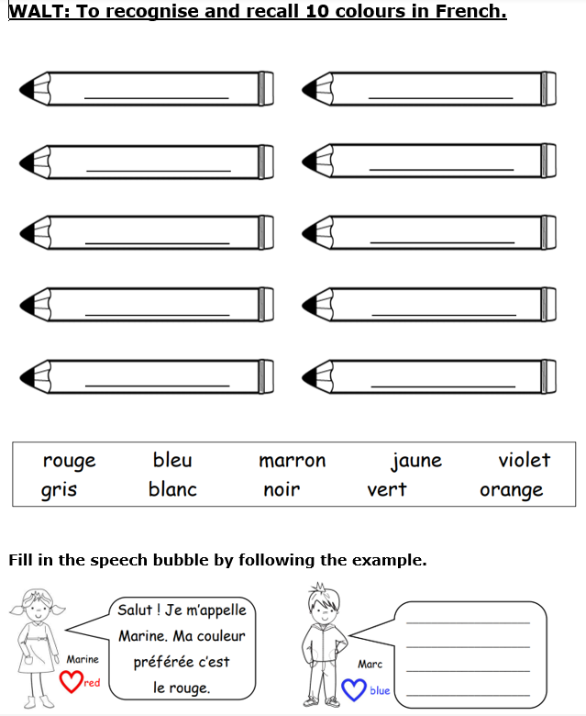
Retrieval opportunities | Retrieval at the beginning of the lesson-vocabulary (verbal or writing activity)  Vocabulary displayed in the classroom  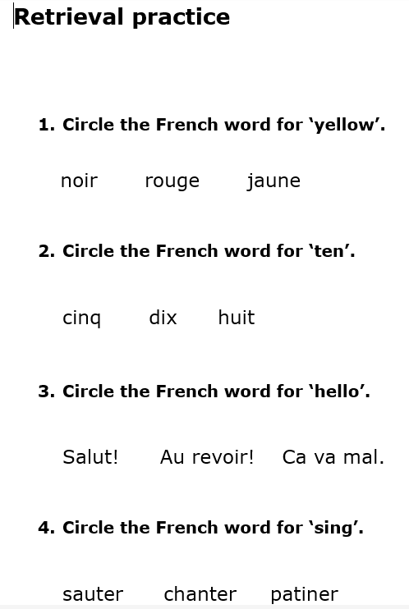
Assessment | End of Unit assessment – to be placed in books  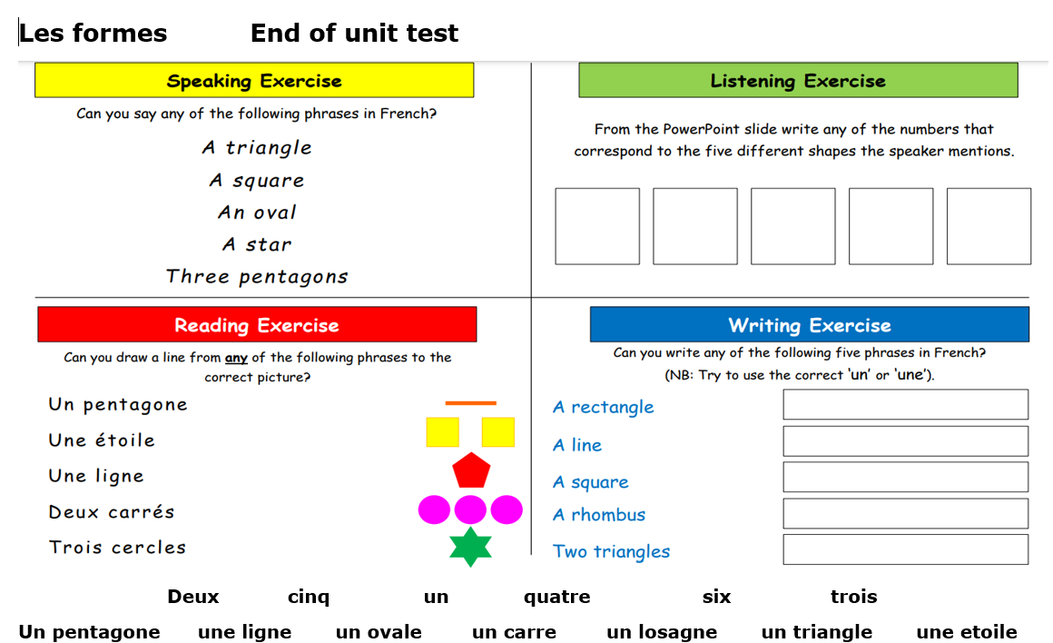
Working Wall | Vocabulary displayed in the classroom  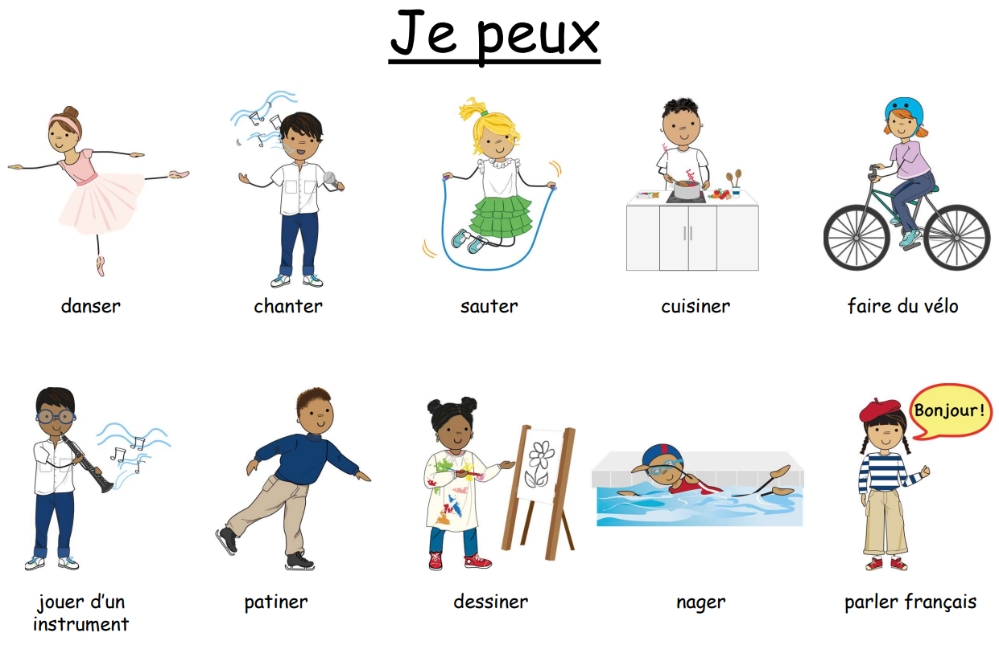
Marking & Feedback | Follow Marking & Feedback Policy
SEND Adaptations | Use of Teacher Toolkit  Adaptions for application activities  Individualised SEND support

