
Implementation Expectations
Design Technology

Scheme | 
Timetable / Duration | - DT and Art are taught alternatively every other half term.  - DT is taught in Autumn 2, Spring 2 and Summer 2 terms as a discrete lesson, once a week, 1 hour per week.
Sequence of Lessons  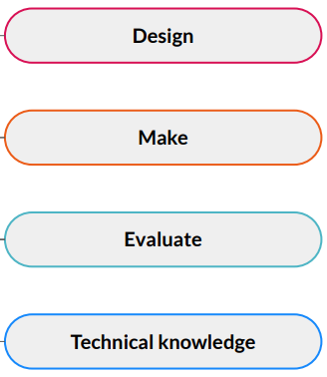 | - Each unit usually has between 4 and 6 lessons.  - Some lessons may need splitting depending on what children have already learnt in previous year groups.  - Some units may be more familiar to the children than others (e.g cooking).  - Digital World (KS2) uses Microbits and CAD software which children may need extra recap lessons of previous learning.  - Each unit starts off with research then designing a product, making it and then evaluating it. Technical knowledge is used throughout the units building on previous skills.
Lesson Structure  (What a typical lessons look like) | - Retrieval / recap from previous lesson at the beginning of every lesson.  Use ‘presentation mode’ in Kapow and follow through the slides.  - Learning Objective  - Success Criteria  - Key Vocabulary  - Attention Grabber (Questions to consider) videos to watch.  - Main event/input  - Independent activities  - Wrapping Up/Quiz
Expectations in Books | - Short date and WALT at the top of the sheet  - Worksheet stuck in or photographs of a practical lesson explaining what the children are doing in that lesson. Children annotate photographs where necessary,
Retrieval opportunities | - Retrieval section at the beginning of every lesson – knowledge and vocabulary  - Wrapping Up / Quiz at the end of each lesson  - Working Wall  - Brain Dump, List it, Give me 5.  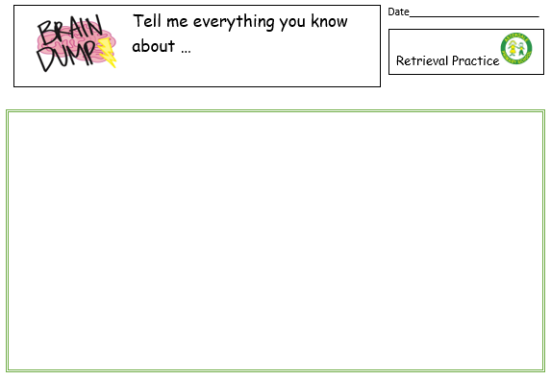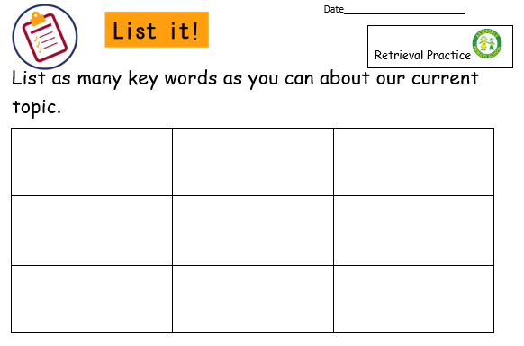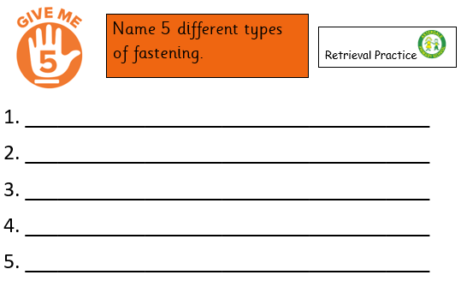
Assessment | - Post-assessment – to be placed in books at the end of the unit  - Use the Kapow assessment/quiz of multiple choice.  - Complete the assessment/quiz at the end of each unit and stick in books.  - KS1 - 5 questions, KS2 – 10 questions.  - Record children’s scores for each unit out of 5 or 10.  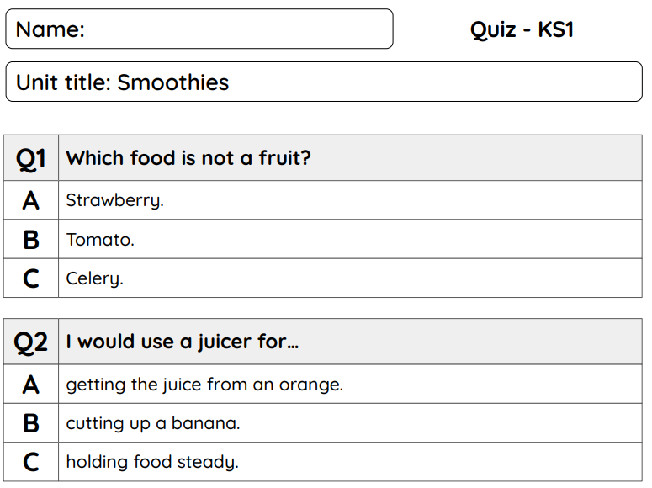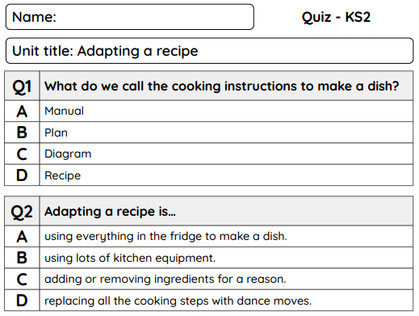
Working Wall | - Display the title of the unit.  - Vocabulary dozen for the current unit.  - Examples of children’s work.  - Photographs of practical lessons.
Marking & Feedback | Follow Marking & Feedback Policy
SEND Adaptations | - Use of Teacher Toolkit  - Adaptation of independent activities  - Individualised SEND support  - Adaptations of resources

